Section/Unit: SIT
NATIONAL APPRENTICE & INDUSTRIAL TRAINING AUTHORITY INSTRUCTION SHEET
FOR INDUSTRIAL TRAINING UNDER THE INDUSTRIAL TRAINING SCHEME
DOCUMENT •ro BE FILLED ON COMMENCEMENT OF TRAINING

Contrgct Apprenticeship
The apprentice, employer and 2 witnesses should sign the contract form in 3 copies. All copies should be sent to NAITA for registration

Worksite Form
2 copies should be properly filled & signed by the appientice. One copy should be sent to NATA and other copy to the relevant University or Institute. After reporting for industrial training if there is any change in your work site, please inform both authorities without delay.

Novation of Contract
Issue No: 01 | Reviewed by: | Page No:
Issue Date: 01.11.2014 | Approved by: | Doc.Ref.No: srr/PU7
The apprentices Will bc required to forward the duly compteted "Novation of Contract" Forms (3 copies) to the contact adds-ess in case they repos; at another establishment for training. The first employer, second employer and the apprentice with two witnesses should sign 3 copies of the form.
RECORDLNG TRAINING

Record of Progress — Daily Diary
Ali apprentices should maintaiu a daily diary for recording their progress in training and it should be submitted to the
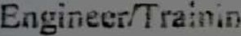Otteer the training estabfls.hment the end of each for comments & certification. This record book should always be with the trainee so thai the training- supervising officer on inspection could monitor the progress in training individually.

Report on Training
On completion of each period of training, the trainee should prepare a report on hiéher training which should be submitted to the training evaluation panel.
BEHAVIOUR AT TRAINING

Maintain ing Discipli ne
As the training followed by the apprentice is a compulsory course requirement for his/her finai certificate, it is expected that the apprentice will show interest and be amenobte to discipline. However, in term of the contract of apprenticeship. the apprentice wili be governed by the rules and regulation of the establishment where he/she undergoes training. The employer may take any measure deemed necessary in consultation with the NAITA Special Industrial Training Division, to ensure proper and appropriate conduct Of the apprentice

Section/Unit: SIT
Mode of Taking Leave
For each month completed, the leave entit:ements are % day casual and Oi day medical. Anyhow in a special case the trainee may take the full leave quota per period on approved leave basis. No trainee will be permitted to take leave unless the trainee supervising officer of the training establishment has granted prior approval.
Accommodation
The responsibility for finding suitable accommodation rests entirely with the apprentice. However, wherever possible the assistance of the employer in this regard is greatly appreciated.
OTHER IMPORTANT MATTERS TO BE NOTE
On commencement if any apprentice fails to report for training within the presc.•ibed period without tendering a valid excuse in writing, it will be presumed that he/she is no longer interested in the in- plant training. After a reasonab!e period of time NAITA will delete the name of the trainee from register.
> Apprentice has to comply with the formalities of signing the contract of apprenticeship training and notifying the location of training in order to effect monitoring and assessment of training at the end.
Once decided on, there is no possibility of changing the training establishment or effecting mutual transfers, as the document of apprentices would have already been forwarded to the respective establishment for notification and action.
The Telephone Numbers of the NAITA Special Industrial Training Division is 01 1-288782-5 extension 209/287 and 01 1. 2863680/ 01 1-2867435(Fax)
Trainees are considered to be part of the work force and they should conduct themselves by adhering to the rules and regulation of the organization.
All communications should be in writing and address to the Special Industrial Training Division, NAITA Head
Office.
No trainee may extend the trainee period without prior approval from NAITA, and if such training has taken place it will be considered as lost training.
NAITA discourages taking leave against the training period (ex. For study leave), if such leave has been granted, an extension of the training period will be decided upon.
No payment will be made to the trainees by NAITA while on training.
It should be noted that NAITA would assist to provide training to the trainees maintain good behavior in industry. If due to any misconduct the industry refuses to provide training to the student, NAITA may also refuse to undertake further the training activity.
COMMIUNICATION WITH NAITA
Assistant Director
Special Industrial Training Division
National Apprentice & Industrial Training Authority
971, Sri Jayawardenepun Mawatha
Welikada Raiagiriyn,
Issue No: 01 Reviewed by: Page No:
Issue Date: 01.11.2014 Approved by: Doc.Ref.No: SIT/PL/7

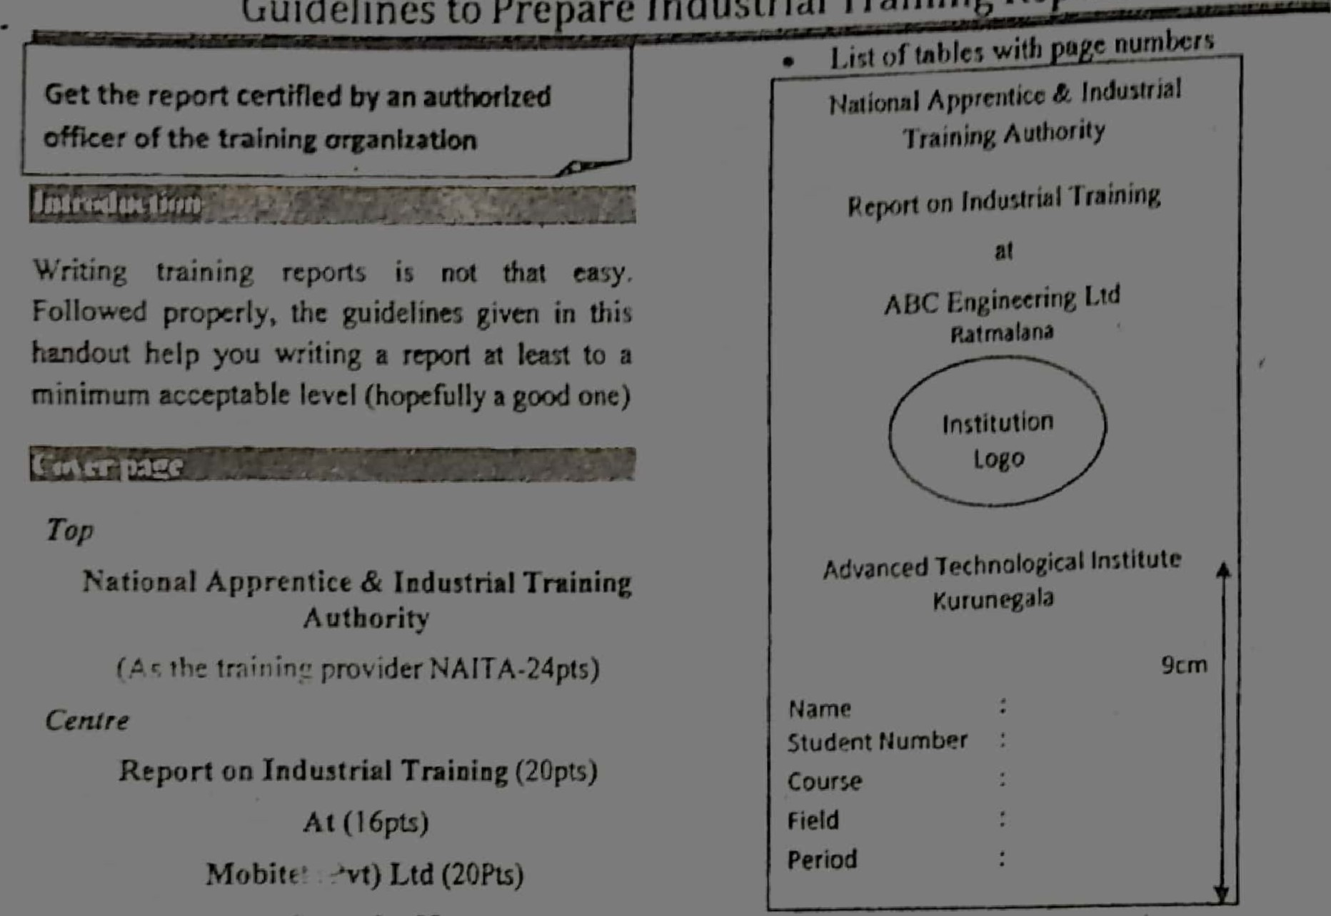
C •ombo 08
G
uidelines
to
Prepare
Industri
al
T
raining
Report
Bottom
- Name of the Academic Institute
Advanced Technological Institute
N;tiwala (16pts)
This should be 9 cm above the bottom of the page
Bottom left
- Student details: (14pts)
Name
Student Number
Course
Field
Training Period
Note: Please refer the figure No. I
lor Inner
Include the following before writing chapters
- Acknowled?h'ent
- Preface
- Contents
- List with page numbers
NAtTA
Figure No]; Example ror cover page design
Chapter J
Introduction about Training Institute
- Organizational chart, Nature of business (products (services), Vision, Mission, Goals, Objectives, Number of Employees.
- Management styles/ Administrative practices Ixave, EPF,ETF, Recruitment procedures Compensation , Welfare Activities, Safety measures, Training and development strategies.
- Safety practices
Chapter 2
Your Training at the Institute
- Your creations, (formats, templates, produces,
- How you analyze problems in terms of causes. symptoms and feelings, and the problems faced and how encountered them.
- List of activities performed during the training
SIT Division
e You may include theoretical component but you heye to make comparisons with
applications.
You may inc!ude standard operation procedures foi!owed by%the organiz.ation with comparisons of whet you during academie programme
• Try to include the things that you learnt in addition to the training syliabus o Be aware not to copy or download no!es from tbe Internet or other sources. However, in such a case, you must ir:cFude a list of reference or data sources) ^{e} {r.cEude List of figures and list of tables with page numbe;s

Exampte
Figure C ; Organizat;on char, of "X"  Exs.m.pie 2 | 17
Table t3 chart- phase | 23
When you write the report you may provide the titles for figures and tables as in the examp!es.
Exemple 1 Figure Oi: Organization chart of "X"
Exemple 2 Tabie 03: Activity pian for phase )

Cbapier 3: Conc;usioa to the report
- Suggestions for your own development, treiüing developraent and organizatior.?.! deveiopment etc.
- Your gains, weaknesses identified
Lis^{t}. of activities, tasks that could not as a trainee engineer technician) during the training

Do's
- Use the font style Times New Roman.
- Norma} font size 12 for the chapters
- Headings must be bit higher than font size 12
- Recommended Line space I .5
- Page numbe in center of the page • Justify the content e Use Chapter outline (See APA standards)
- Use Conversational language (Not you but I and we) e Write the report with more than 2000 wcrds/more than 30 pøges
- Include relevant Photos as evidences
- Include Logo of Institute in the cover page Dont'g
^{e} No borders for cover page
- No Headers or footers
- No over emphasizing the topics and subtopics

VISION
The word Vision is overemphasizzd by making the bold, italicized, underlined, capitaliæd(uppcrcase) with 16points font size. Instead a simple emphasizing is encouraged. Ex: Vision
Coaclusioo
Daily diary is the key to complete the training report. The weekly entries provide you pages that can be included the report. For exarcpie if your training is for 3 months there you can have 12 pages. In case it's a 6 months you can have 24 pages. Remember the entries should reflect your real training experiences. Also if you search internet try search words "Reflective journals" herm/concept papers", and "APA standards".
Introductim
1.1 About Training organizations
i.i.l Nature oi business
1.i.2 Organization cha^{r}t
1.2 co -operate plan
1.2.1 Vision
1.2.2
1.243 Objectives
1.2.4 Strategic planning
1.3 Management practices
1.3. i Recruitment procedures
1.3.2 Training and development strategies
2.0 experience
2.2
Example for chapter oud!ne (fot Inner pates)

K. | Training shall ensure that the trainee attends all other training progranunes to be outside the establtshtnent as speci fied under the Training order. |  | The trainee shall observe strickly the rules and regulations of the establishment / training employer
K. |  |  | The trainee shall treat tools , machinery and other equipment installations with due care and only use them for the purpose which they are intended.
 | The trainitV' employer shall allot the trainee only with such work as serves the pumose of the training and is in keeping with the physical abilities and constitution ofthe trainee.
 |  |  | The trainee shall keep all books of records issued for the purpose or training in proper order and duly entered and submit same for regular Inspection by the employer and the inspectorofNAlTA.
 | The Training employer shall ensure that the trainee's character is developed and not exposed to moral or physical hazards.
 | The training employer shall also grant all the necessary leave of absence to the trainee to follow training programtnes or sit for exatninations and Tests referred to in clauses J & K above. | U | The trainee shall observe the business and trade secrets of the trainingemployer.
 | ^{E}  llie Trainee shall make every effort to acquire the skills and knowledge to achieve the training objective as envisaged under the Traini ng order. | V. | The tra inee shall notify the training employer immediately of absence due to sickness, accident or other reason, and submit medical certificates ifnecessary
P. | The trainee shall carry out with due care the work assigned by the training ctnployer during the course oftraining. | W. | The trainee shall be entitled to founeen days of casual leave and seven days of medical leave. Ilowever if the training period is less than one year the above leave entitlement shall apply on a propotionate basis.
Q. | The trainee shall adhere to all directions issued as part of training by the training employer the trainer or any other authorised person. | W.
GENERAL
It is also hereby agreed between the training employer and the trainee that the following general rules apply during the period of this contract
- That the trainee shall be covered by the Workmen's Compensation Ordiance an the Factories Ordinance;
- \Vhere the training contract of a trainee is terminated after the completion of the probationary period through the failure of the training employer to carry out the terms and conditions of this contract, he shall pay to the trainee, compensation, the quantum of which shall be determined by the NAITA and where this contract is terminated after the completion of the probationary period through the failure ofthe trainee to carry out the terms and conditions, ofthe contract, he or his legal representative shall pay to the employer compensation, the quantum ofwhich shall bc determined by the NAITA. All procedure to be followed in this regard shall strictly be in accordance with the provisions set out in Act No. 20 of 1990 and regulations made thereunder.
- that any disputes arising between parties to this contract related to training shall be referred to the Chairman NAITA for arbitration,
The decision ofthe Chairman NAITA shall be Final.
- The trainee shall be considered as a "Workman" as defined under the 
Sig. of Training Employer Sig. of%fnee/Parent of guardian
Name
Name
Address
(Company Seal)
On This

Witness for employer | Witness for Trainee
Natne  Address | Signature |  | Name  Address |  | Signature
Doc No : Trg/App/f-7
issue NO : 02 | Reviewed by
Date : 0,1.05.2016 | Approved by :
This Contract is approved and entered in the Register of Training contracts under Tertiary and Vocational
Education Act No: 20 of 1990
No: | Stamp:  Signature:
On: | Stamp:  Signature:
National Apprentice and Industrial Training Authority 971, Sri Jayawardanapura Mawatha, 9,'eIikada, Rajagiriya.

TRAINING CONTRACT
(Under the provision of section 65 ofthe Act No: 20 of 1990)
(Notes on the Training Contract)
The training employer will be registered on the register of training contracts at the National Apprentice and Industrial Training Authority innuediately after registration or prior to the commencement of training whichever is the earliest. All copies of this contract must be appended. TIIC same applies to amendments to the provisions of this contract by reason of extension of training periods, termination or any such matter. All such amendments to this contract shall be permissible only after prior approval is granted by NA ITA. It is the responsibility ofthe training employer to hand over a duly certified copy of this contract after obtaining registration at
NAITA,
The training employer is required to infonn NAITA the trainee has been absorbed into regular employtnent in his establishment.
BETWEEN
AND
The Training Ernployer The Trainee
Name of the Firm   Lobs(pvC) |  | c: | In Sinhala |   DØé)32c2J9
 |  | c: | In English |  | 
Address


1 02 go
Tele: No:
209 CtAeoepc•
5åma It.-ff.,
Address
Kadl
Date ofBirth I g — og- gg7
3023 Cc a) N.l.CNo.. 633 044 v Male/Female
WHEREAS the Training Employer has agreed to engage the Trainee for the purpose ofproviding INITIAL TRAINING/FURTI IER TRAINING / RE-TRAINING in theTRAINEE OCCUPATION OF.... I.E..a.i. n.e.p.......foF.L ceG!.e.... 
e
e.p-
AND WI IEREAS the said Trainee Employer and Trainee have agreed to abide by the provisions ofTertiary and Vocational Education
Act. No, 20 of 1990 and the regulations made there under which govern such train ing in Sri Lanka;
The following contract is hereby entered into between the aforesaid Training Employer and the Trainee:
  The duration of training according to the Training order recognised under Act. No. 20 of 1990 shall be a period of | F. The training employer shall pay the Trainee a suit able gross allowance of Rs.J. ^{O}..sQO.Q.. per month or such sum as may be determined from time to time by the National Apprentice and Industrial TrainingAuthority.
 | G.The Training employer shall ensure that skills and knowledge are imparted to the Trainee in accordance with the training objectives laid down in the Training Order and that the relevant subject matter is covered and the training objectives are achieved within the stipulated training duration
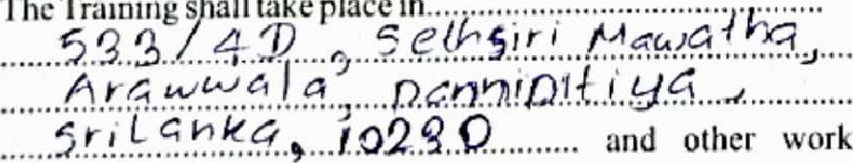and other work places usually associated with the headquarters ofthe Firm.
B.
The
Trainings
Il
take
place
in.
 | H.The training employer shall itnpart the training himself if suitably qualified, or through other suitably qualified employees in his establish Inent.
C. The regular weekly training hours shall be 45 1/2 hours. | I. The training etnployer shall provide the trainee with a copy of the Tra ining order at the cornmencetnent oftrain ing.
l). The nature, content and syllabus for training. during the entire period of training shall substantially conform to the Training order provided for such trainee occupation. | J. The training employer shall provide the trainee with training aids and equipment and in particular training tools, consumable and literature necessary for training in the establishment and shall also provide the trainee all the facilities required by the trainee to sit the examinations and National Trade Tests conducted by the National Apprentice and Industrial Training Authority in the 'Trainee Occupation such trainee is undel going traintng.
E. The probation period shall be three months for Training courses of duration up io two years, and six months for training courses ofduration ofjnore than two years.

No ; 02 | Reviewed by •
oate .040%2016 | Approved by : | Continued
ooc No .7
Section/Unit: Special Industrial Training:
Section Code: SIT
ATIONAL APPRENTICE AND INDUSTRIAL TRAINING AUTHORITY
WORK SITE FORM:
Date•
Assistant Director,
Special Industrial Training Division,
National Apprentice and Industrial Training Authority
971, Sri Jayawardenapura Mw,
Welikada, Rajagiriyae
PARTICULARS OF WORK SITE/I,OCATION/RESIDEN AL ADDRESS DURING APPENTICESHIP TRAINING
This form should be completed and returned to NAITA on the commencement of the Apprenticeship Training when any changes occur in these particulars during training, it should be notified within one week from commencement of such changers in training.
NAITA allocated Training Establishment'
Name of Apprentice E ceoE000hoge
C amodtdG L GYQ_5i'
Residential Address
(During Apprenticeship) 5.GtmG.g,jVC1" coa105hrql]a ,
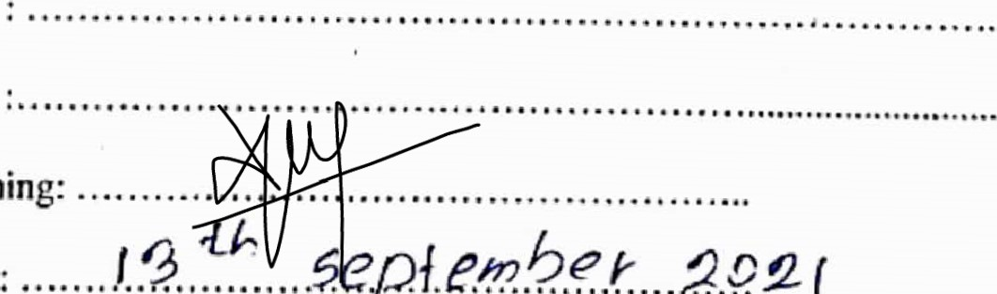
Telephone No.
Pf.æ.4€..t....2.Q2
(
4-gz-f
Name & Address of work site

Designation & Name of the Officer in-charge of training
Phone No
Signature of the officer in-charge of training•
Date of commencement of Training
Category of Apprentice ( Degree/DipIoma/NVQ 5/6 )
Name of the Course & Field of 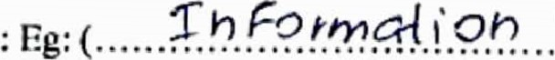qæ.ßh?.logg Study
1 agree to bring the completed Daily Diary to the training place every day.
Name of Institute/University  06 Tech hObgg
C(h/vPrSi4g | Of | 0 | 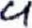
Signature of the Apprentice 
Issue No. 02 issue Date: 15.06.2015 | Reviewed by:
Approved byDoc. No: SIT/PL [Fm /06

